**VLSI**

**PROJECT**

BY :

SHIVANG SHARMA

**ABSTRACT :**

##### Basic circuits written in Verilog HDL, simulated and implemented on the FPGA.

**OBJECTIVE** **:**

To implement and observe the output waveforms using Verilog and Xilinx vivado

of the following circuits:

* Half adder
* Full adder
* Half subtracter
* Full subtracter
* Encoder
* Decoder
* Multiplexer
* Demultiplexer
* Comparator
* All basic gates
* D flip flop
* JK flip flop

**INTRODUCTION :**

Verilog is a HARDWARE DESCRIPTION LANGUAGE (HDL). It is a language used for describing a digital system like a network switch or a microprocessor or a memory or a flip−flop. It means, by using HDL we can describe any digital hardware at any level. Designs, which are described in HDL are independent of technology, very easy for designing and debugging, and are normally more useful than schematics, particularly for large circuits.

We will use Verilog to implement the circuits on FPGA board using Xilinx vivado. Field Programmable Gate Arrays (FPGAs) are semiconductor devices that are based around a matrix of configurable logic blocks (CLBs) connected via programmable interconnects. FPGAs can be reprogrammed to desired application or functionality requirements after manufacturing. This feature distinguishes FPGAs from Application Specific Integrated Circuits (ASICs), which are custom manufactured for specific design tasks.

Here we do not have a FPGA board so we will implement the circuits in Xilinx vivado itself.

**METHODOLOGY :**

First we need to make truth table of the circuit, then using this truth table derive the Boolean expression of the output using simplification or K-Map. In Verilog, we have to benches namely design bench and test bench.

DESIGN BENCH : Give the name of the module and specify all the input and output port.

Then, with the help of the Boolean expression derived above, design circuit by any of the modelling techniques namely Gate level, Dataflow and behavioral modelling.

TEST BENCH : Mention all the input and output of the circuit as register , wire ,etc.

Set initial values of input under INITIAL block. Now to verify the circuit, check the output with different values of input which can be done under ALWAYS block.

Finally run stimulation and observe the waveform to verify the working of the circuit.

**CODE :**

* **HALF ADDER**

|  |  |
| --- | --- |
| **TEST BENCH** | **DESIGN BENCH** |
| module testbench();  reg a;  reg b;  wire sum;  wire carry;  half_adder uut(.a(a) , .b(b), .sum(sum), .carry(carry));  initial  begin  a=0;  b=0;  end  always  begin  #10 a=~a;  #10 b=~b;  end  always  #100 $finish;  endmodule | module half_adder(  input a,  input b,  output sum,  output carry  );  xor(sum,a,b);  and(carry,a,b);  endmodule |

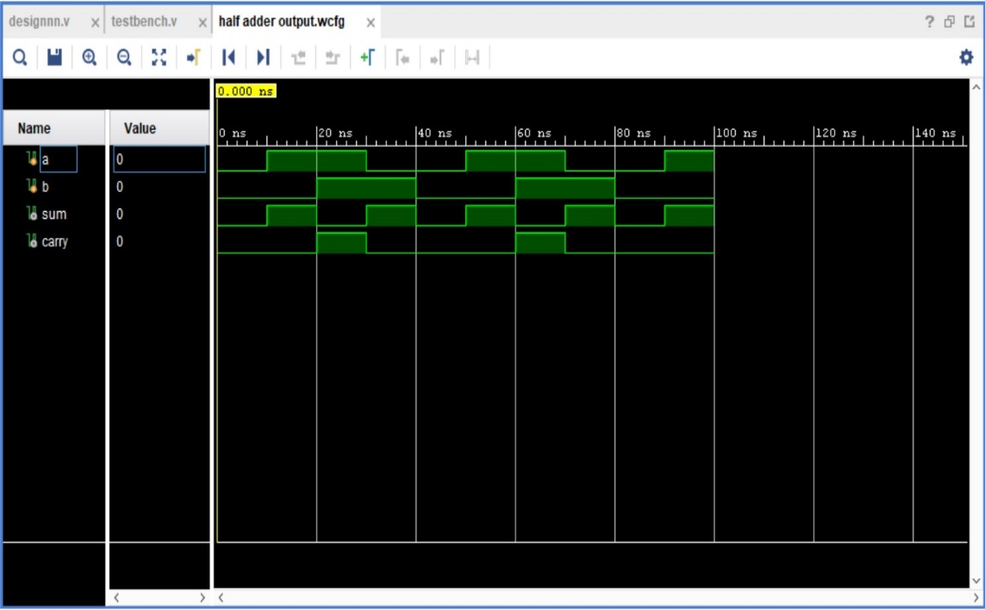

* **FULL ADDER**

|  |  |
| --- | --- |
| **TEST BENCH** | **DESIGN BENCH** |
| module testbench();  reg a;  reg b;  reg carry_in;  wire sum;  wire carry_out;  full_adder uut(.a(a),.b(b),.carry_in(carry_in),.sum(sum),  .carry_out(carry_out));  initial  begin  a=0;  b=0;  carry_in=0;  end  always  begin  #10 carry_in=~carry_in;  #10 b=~b;  end  always  #40 a=~a;  always  #300 $finish;  endmodule | module full_adder(  input a,  input b,  input carry_in,  output sum,  output carry_out  );  assign sum = a^b^carry_in;  assign carry_out = (a&b)+((carry_in)&(a^b));  endmodule |

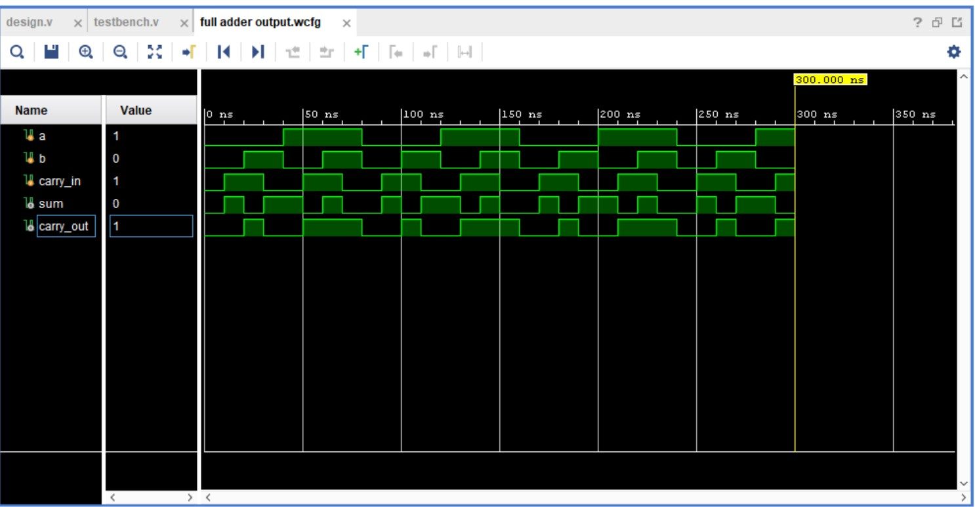

* **HALF SUBTRACTER**

|  |  |
| --- | --- |
| **TEST BENCH** | **DESIGN BENCH** |
| module testbench();  reg a;  reg b;  wire difference;  wire borrow;  half_subtractor uut(.a(a),.b(b),.difference(difference),  .borrow(borrow));  initial  begin  a=0;  b=0;  end  always  begin  #10 a=~a;  #10 b=~b;  end  always  #300 $finish;  endmodule | module half_subtractor(  input a,  input b,  output difference,  output borrow  );  assign difference = a^b;  assign borrow =(~a)&b;  endmodule |

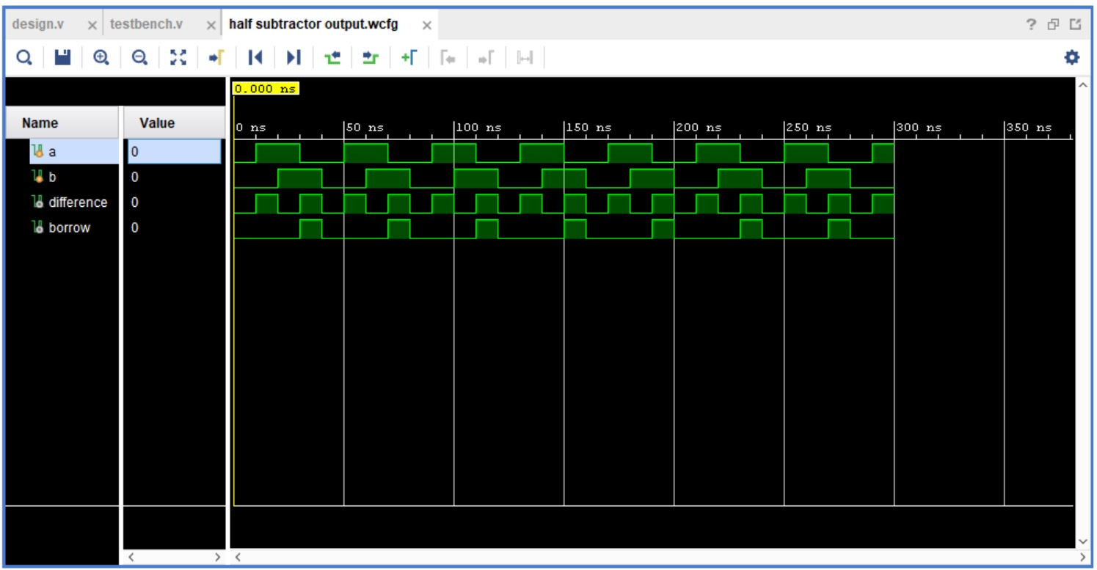

* **FULL SUBTRACTER**

|  |  |
| --- | --- |
| **TEST BENCH** | **DESIGN BENCH** |
| module testbench();  reg a;  reg b;  reg borrow_in;  wire difference;  wire borrow_out;  full_subtractor uut(.a(a),.b(b),.borrow_in(borrow_in),  .difference(difference),.borrow_out(borrow_out));  initial  begin  a=0;  b=0;  borrow_in=0;  end  always  begin  #10 borrow_in=~borrow_in;  #10 b=~b;  end  always  #40 a=~a;  always  #300 $finish;  endmodule | module full_subtractor(  input a,  input b,  input borrow_in,  output difference,  output borrow_out  );  assign difference = a^b^borrow_in;  assign borrow_out = ((~a)&b)+((borrow_in)&(~(a^b)));  endmodule |

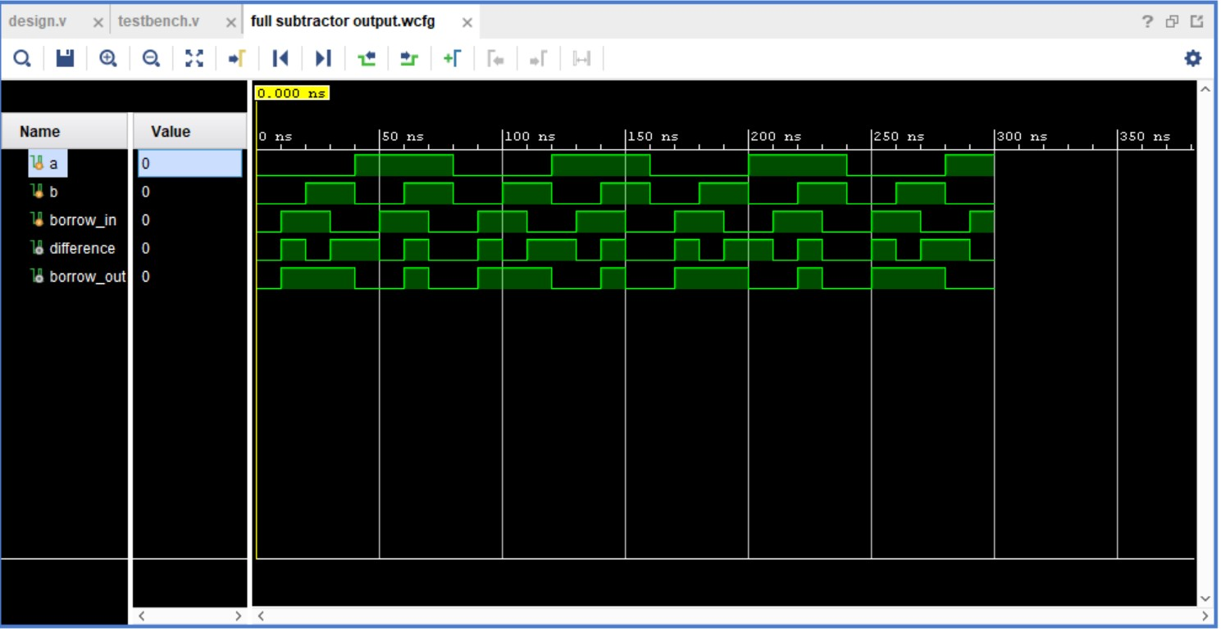

* **ENCODER**

|  |  |
| --- | --- |
| **TEST BENCH** | **DESIGN BENCH** |
| module testbench();  reg [7:0]y;  wire a2;  wire a1;  wire a0;  encoder_8to3 uut(.y(y),.a2(a2),.a1(a1),.a0(a0));  initial  begin  y[0]=0;  y[1]=0;  y[2]=0;  y[3]=0;  y[4]=0;  y[5]=0;  y[6]=0;  y[7]=0;  end  always  begin  #10 y=8'b00000001;  #10 y=8'b00000010;  #10 y=8'b00000100;  #10 y=8'b00001000;  #10 y=8'b00010000;  #10 y=8'b00100000;  #10 y=8'b01000000;  #10 y=8'b10000000;  end  always  #300 $finish;  endmodule | module encoder_8to3(  input [7:0]y,  output a2,  output a1,  output a0  );  assign a2=y[7]+y[6]+y[5]+y[4];  assign a1=y[7]+y[6]+y[3]+y[2];  assign a0=y[7]+y[5]+y[3]+y[1];  endmodule |

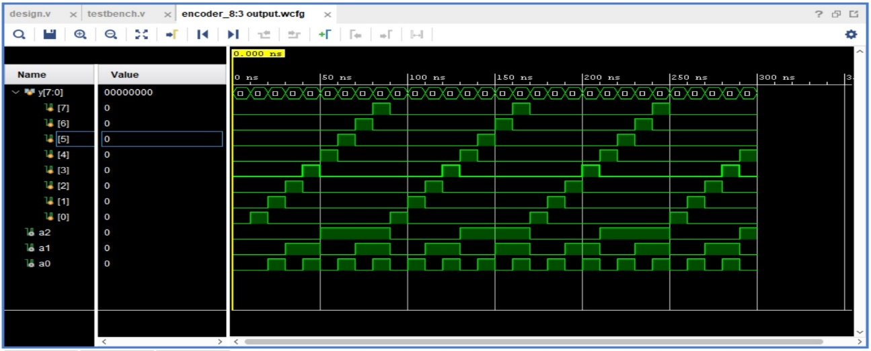

* **DECODER**

|  |  |
| --- | --- |
| **TEST BENCH** | **DESIGN BENCH** |
| module testbench();  reg a0;  reg a1;  reg a2;  wire [7:0]y;  decoder_3to8 uut(.y(y),.a2(a2),.a1(a1),.a0(a0));  initial  begin  a0=0;  a1=0;  a2=0;  end  always  begin  #10 a0=~a0;  #10 a1=~a1;  a0=~a0;  #10 a0=~a0;  #10 a2=~a2;  a1=~a1;  a0=~a0;  end  always  #300 $finish;  endmodule | module decoder_3to8(  input a0,  input a1,  input a2,  output [7:0]y  );  assign y[7]=a0&a1&a2;  assign y[6]=(~a0)&a1&a2;  assign y[5]=a0&(~a1)&a2;  assign y[4]=(~a0)&(~a1)&a2;  assign y[3]=a0&a1&(~a2);  assign y[2]=(~a0)&a1&(~a2);  assign y[1]=a0&(~a1)&(~a2);  assign y[0]=(~a0)&(~a1)&(~a2);  endmodule |

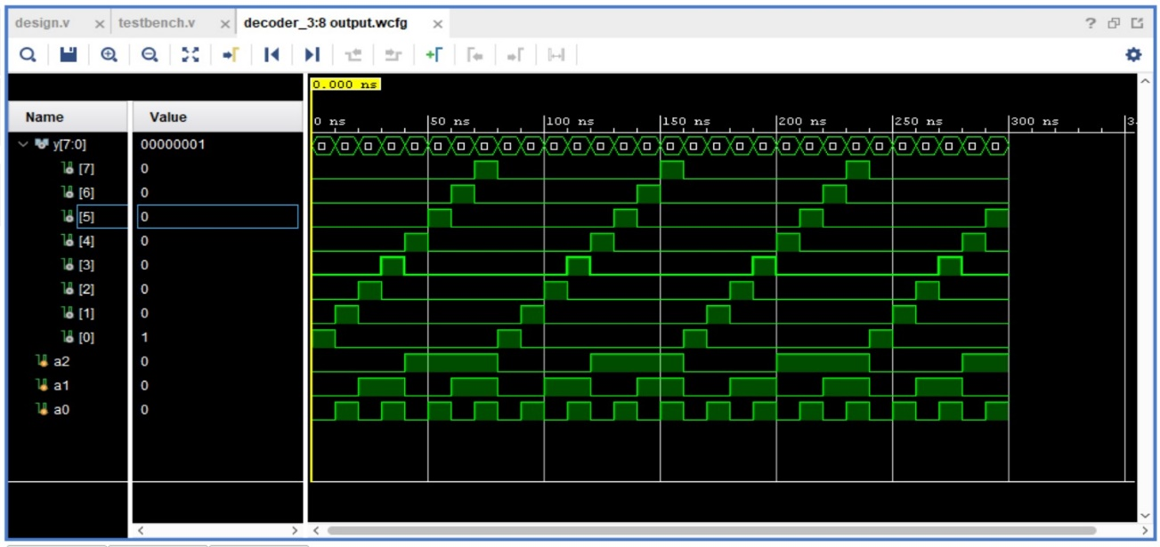

* **MULTIPLEXER**

|  |  |
| --- | --- |
| **TEST BENCH** | **DESIGN BENCH** |
| module testbench();  reg [7:0]i;  reg [2:0]s;  wire y;  multiplexer_8to1 uut(.y(y),.s(s),.i(i));  initial  begin  s=3'b000;  i=8'b00000000;  end  always  begin  #10 s[0]=~s[0];  #10 s[1]=~s[1];  s[0]=~s[0];  #10 s[0]=~s[0];  #10 s[2]=~s[2];  s[1]=~s[1];  s[0]=~s[0];  end  always  begin  #40 i=8'b0000_0001;  #40 i=8'b0000_0010;  #40 i=8'b0000_0010;  #40 i=8'b0000_0100;  #40 i=8'b0000_1000;  #40 i=8'b0001_0000;  #40 i=8'b0010_0000;  #40 i=8'b0100_0000;  #40 i=8'b1000_0000;  end  always  #500 $finish;  endmodule | module multiplexer_8to1(  input [7:0]i,  input [2:0]s,  output y  );  reg y;  always@(s or i)  begin  if(s==3'b000)  y=i[0];  else if(s==3'b001)  y=i[1];  else if(s==3'b010)  y=i[2];  else if(s==3'b011)  y=i[3];  else if(s==3'b100)  y=i[4];  else if(s==3'b101)  y=i[5];  else if(s==3'b110)  y=i[6];  else if(s==3'b111)  y=i[7];  end  endmodule |

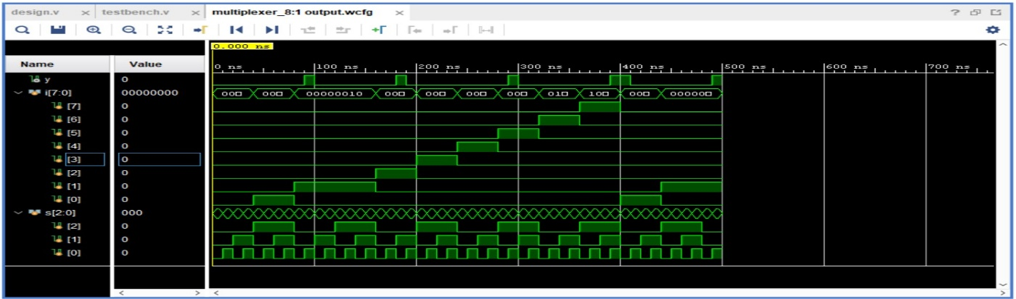

* **DEMULTIPLEXER**

|  |  |
| --- | --- |
| **TEST BENCH** | **DESIGN BENCH** |
| module testbench();  reg a;  reg [2:0]s;  wire [7:0]y;  de_multiplexer_1to8 uut(.y(y),.s(s),.a(a));  initial  begin  s=3'b000;  a=0;  end  always  begin  #10 s[0]=~s[0];  #10 s[1]=~s[1];  s[0]=~s[0];  #10 s[0]=~s[0];  #10 s[2]=~s[2];  s[1]=~s[1];  s[0]=~s[0];  end  always  begin  #5 a=~a;  end  always  #500 $finish;  endmodule | module de_multiplexer_1to8(  input a,  input [2:0]s,  output [7:0]y  );  assign y[0]=((~s[0])&(~s[1])&(~s[2]))&(a);  assign y[1]=((s[0])&(~s[1])&(~s[2]))&(a);  assign y[2]=((~s[0])&(s[1])&(~s[2]))&(a);  assign y[3]=((s[0])&(s[1])&(~s[2]))&(a);  assign y[4]=((~s[0])&(~s[1])&(s[2]))&(a);  assign y[5]=((s[0])&(~s[1])&(s[2]))&(a);  assign y[6]=((~s[0])&(s[1])&(s[2]))&(a);  assign y[7]=((s[0])&(s[1])&(s[2]))&(a);  endmodule |

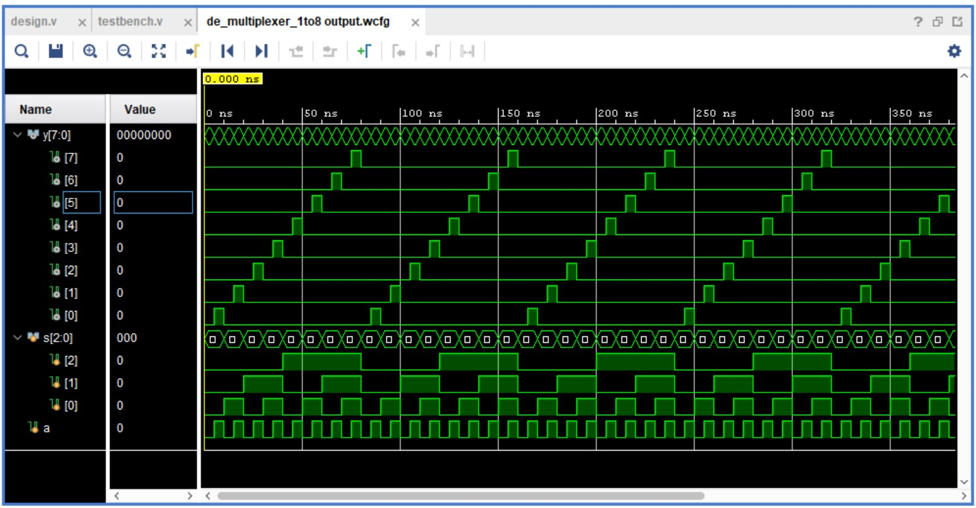

* **COMPARATOR**

|  |  |
| --- | --- |
| **TEST BENCH** | **DESIGN BENCH** |
| module testbench();  reg [3:0] a;  reg [3:0] b;  wire less;  wire equal;  wire greater;  comparator_4bit uut (  .a(a),  .b(b),  .less(less),  .equal(equal),  .greater(greater)  );  initial  begin  a=4'b0000;  b=4'b0000;  end  always  begin  #10 a=4'b0001;  #10 b=4'b0001;  #10 a=4'b0010;  #10 b=4'b0010;  #10 a=4'b0100;  #10 b=4'b0100;  #10 a=4'b1000;  #10 b=4'b1000;  end  always  #500 $finish;  endmodule | module comparator_4bit(  a,b,less,equal,greater  );  input [3:0] a;  input [3:0] b;  output less;  output equal;  output greater;  reg less;  reg equal;  reg greater;  always @(a or b)  begin  if(a > b)  begin  less = 0;  equal = 0;  greater = 1;  end  else if(a == b)  begin  less = 0;  equal = 1;  greater = 0;  end  else  begin  less = 1;  equal = 0;  greater =0;  end  end  endmodule |

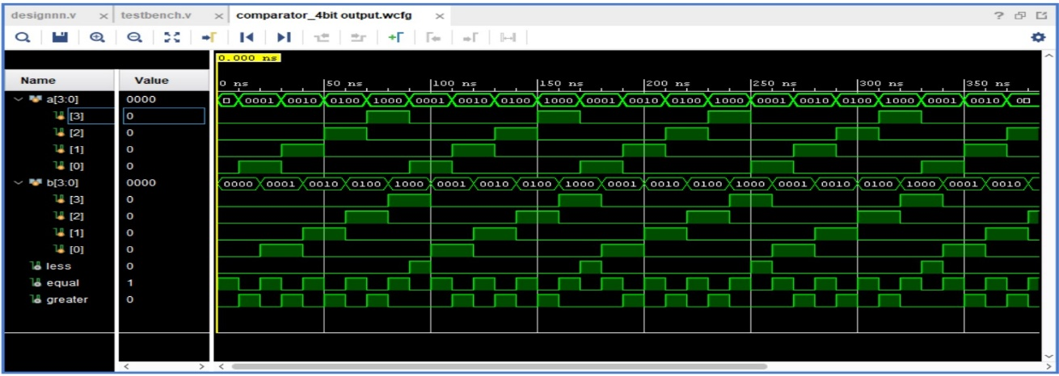

* **ALL GATES**

|  |  |
| --- | --- |
| **TEST BENCH** | **DESIGN BENCH** |
| module all_gates_tb();  reg a;  reg b;  wire not_out1;  wire not_out2;  wire or_out;  wire and_out;  wire nor_out;  wire nand_out;  wire xor_out;  wire xnor_out;  all_gates uut( .a(a),  .b(b),  .not_out1(not_out1),  .not_out2(not_out2),  .or_out(or_out),  .and_out(and_out),  .nor_out(nor_out),  .nand_out(nand_out),  .xor_out(xor_out),  .xnor_out(xnor_out));  initial  begin  a=0;  b=0;  end  always  begin  #10 a=~a;  #10 b=~b;  end  always  #100 $finish;  endmodule | module all_gates(  input a,  input b,  output not_out1,  output not_out2,  output or_out,  output and_out,  output nor_out,  output nand_out,  output xor_out,  output xnor_out  );  not(not_out1,a);  not(not_out2,b);  or(or_out,a,b);  and(and_out,a,b);  nor(nor_out,a,b);  nand(nand_out,a,b);  xor(xor_out,a,b);  xnor(xnor_out,a,b);  endmodule |

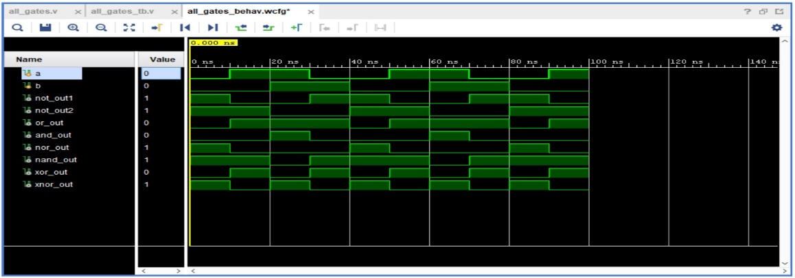

* **D FLIPFLOP**

|  |  |
| --- | --- |
| **TEST BENCH** | **DESIGN BENCH** |
| module testbench();  reg D;  reg clk;  wire Q;  possitive_edge_Dflipflop uut(.D(D),.clk(clk),.Q(Q));  initial  begin  clk=1;  D=0;  end  always  begin  #10 clk=~clk;  end  initial  begin  #10 D<=1;  #20 D<=0;  #30 D<=1;  #10 D<=0;  #10 D<=1;  #60 D<=0;  #20 D<=1;  end;  always  #300 $finish;  endmodule | module possitive_edge_Dflipflop(D,clk,Q);  input D;  input clk;  output Q;  reg Q;  always @(posedge clk)  begin  Q <= D;  end  endmodule |

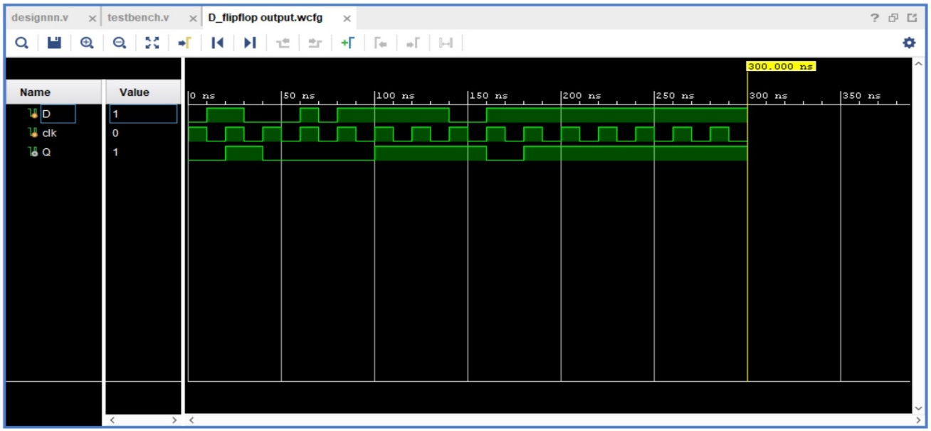

* **JK FLIPFLOP**

|  |  |
| --- | --- |
| **TEST BENCH** | **DESIGN BENCH** |
| module testbench();  reg J;  reg K;  reg clk;  wire Q;  wire Qbar;  possitive_edge_JKflipflop uut(.J(J),.K(K),.clk(clk),.Q(Q),.Qbar(Qbar));  initial  begin  clk=1;  J=1;  K=0;  end  always  begin  #10 clk=~clk;  end  always  begin  #20 J=~J;  #20 K=~K;  end  always  #300 $finish;  endmodule | module possitive_edge_JKflipflop(J,K,clk,Q,Qbar);  input J;  input K;  input clk;  output Q;  output Qbar;  reg Q;  always @ (posedge clk)  case ({J,K})  2'b00 : Q <= Q;  2'b01 : Q <= 0;  2'b10 : Q <= 1;  2'b11 : Q <= ~Q;  endcase  assign Qbar=~Q;  endmodule |

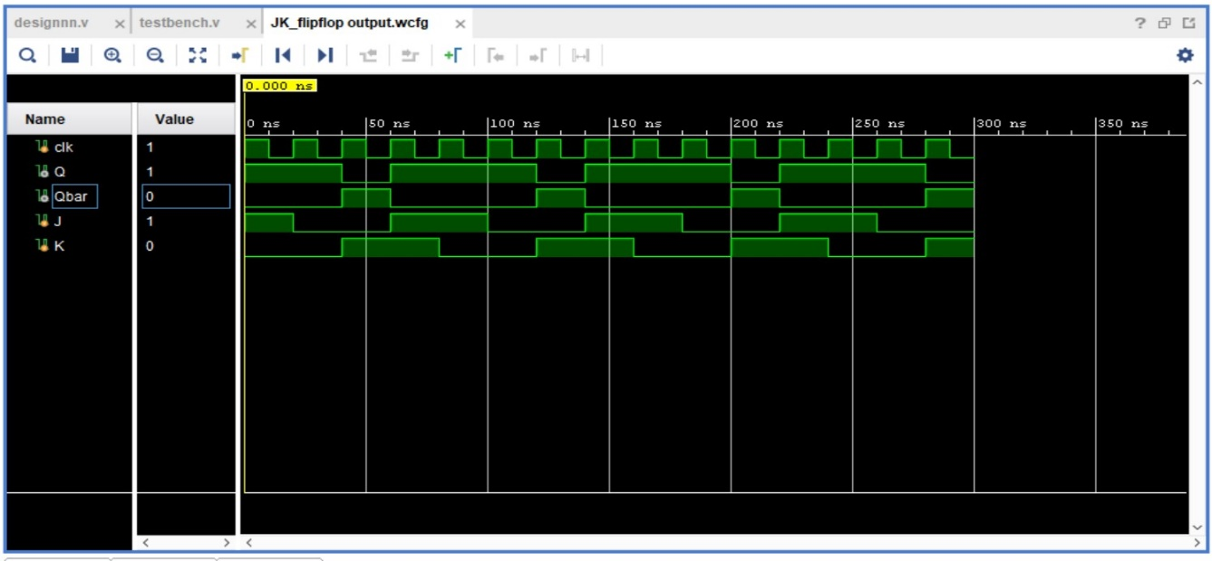

**CONCLUSION :**

Here are the output waveforms of the circuits we implemented on Xilinx vivado

* HALF ADDER

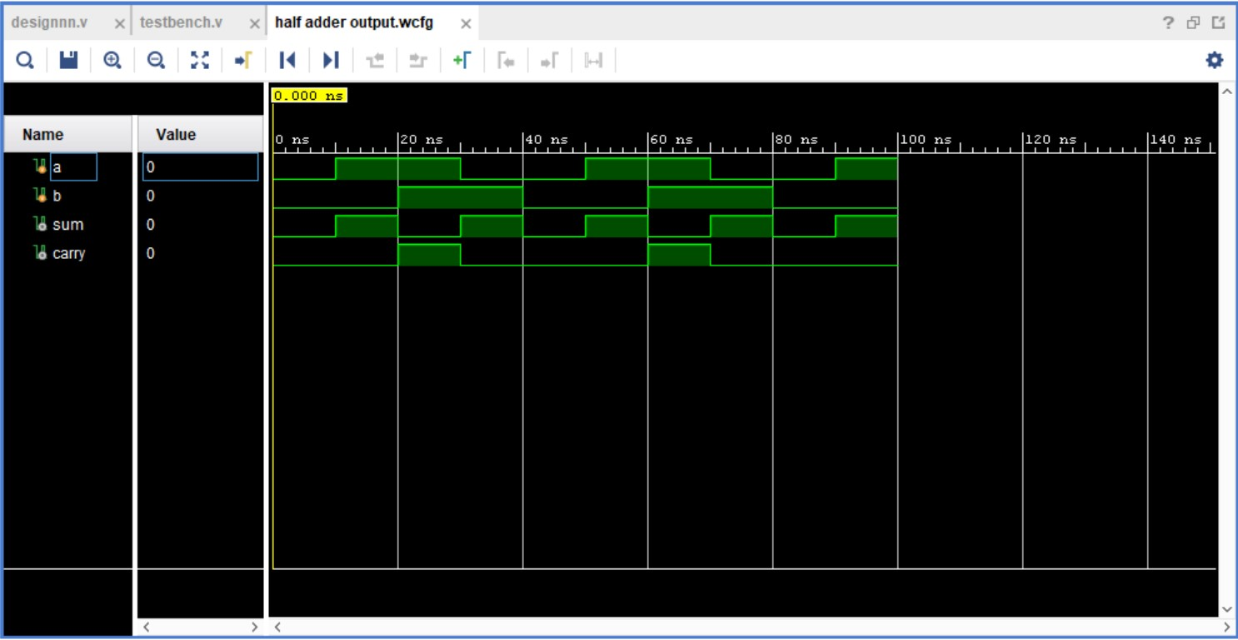

* FULL ADDER



* HALF SUBTRACTER



* FULL SUBTRACTER



* ENCODER

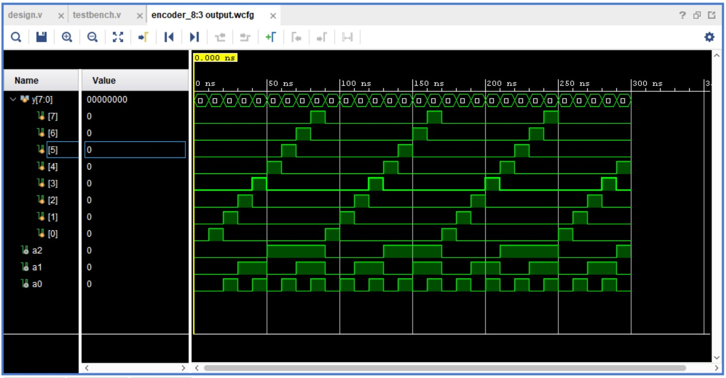

* DECODER

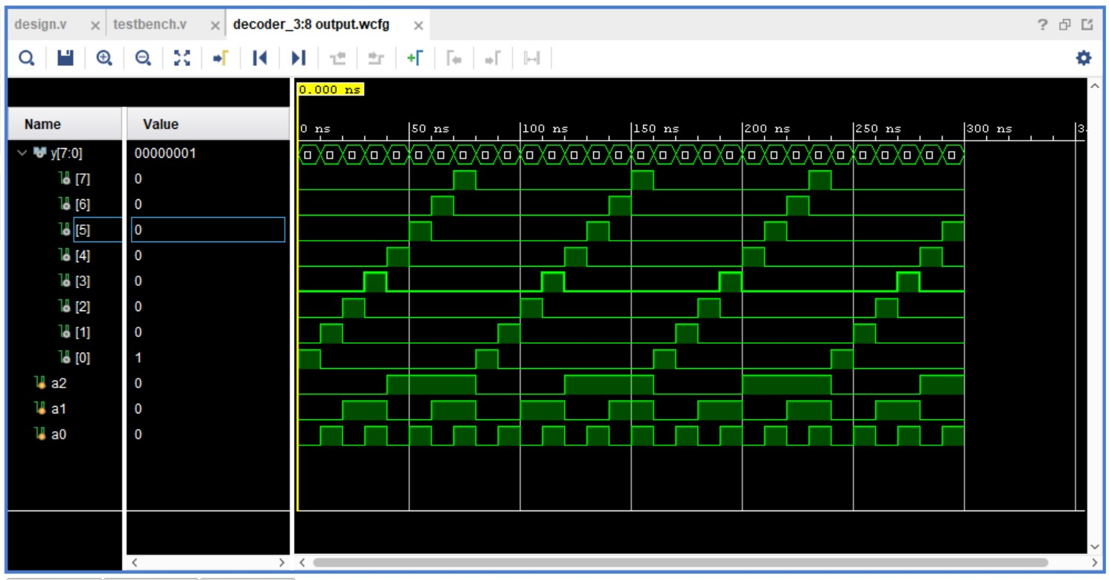

* MULTIPLEXER

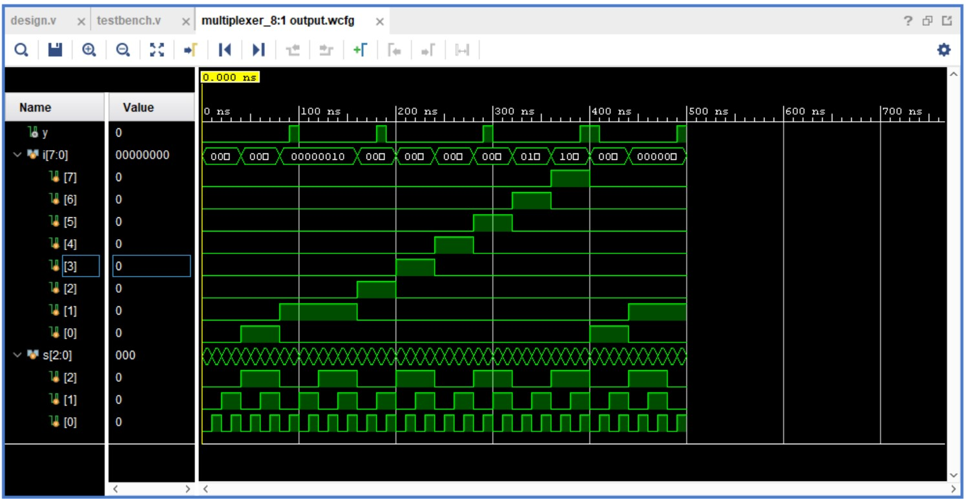

* DEMULTIPLEXER



* COMPARATOR

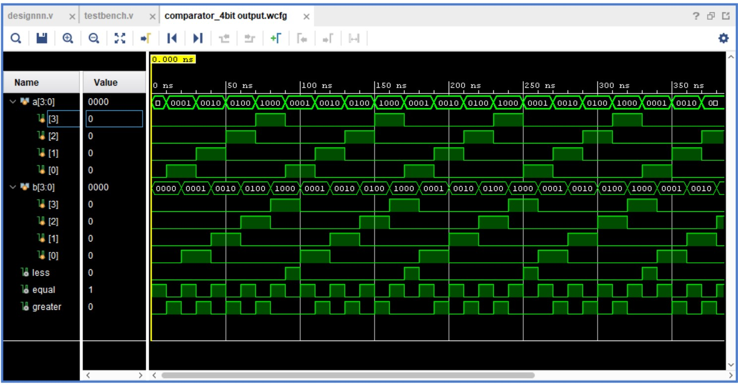

* ALL BASIC GATES

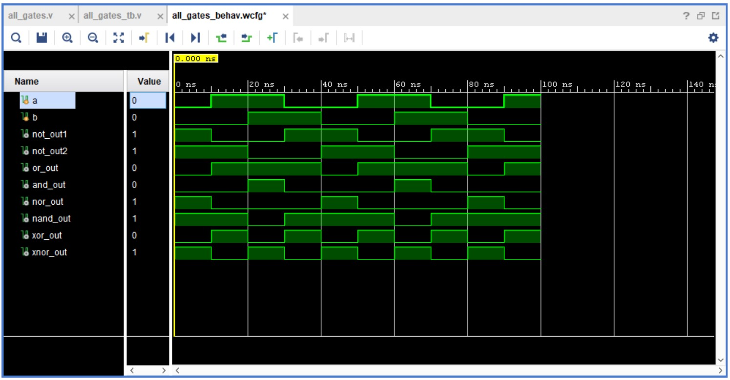

* D FLIP FLOP

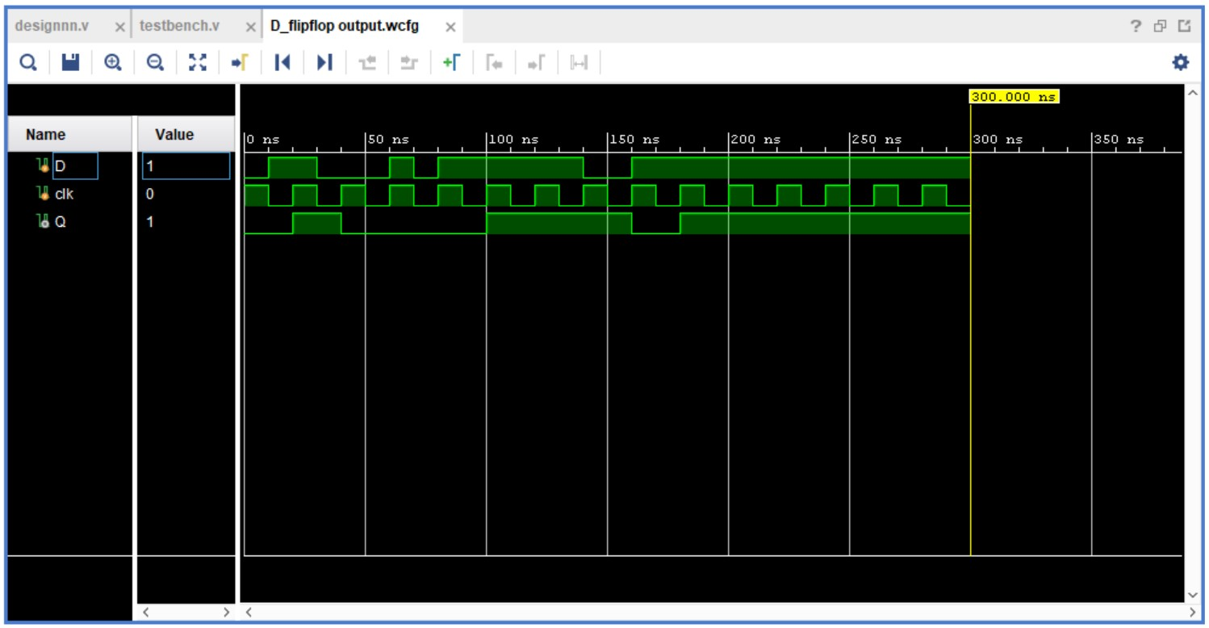

* JK FLIP FLOP

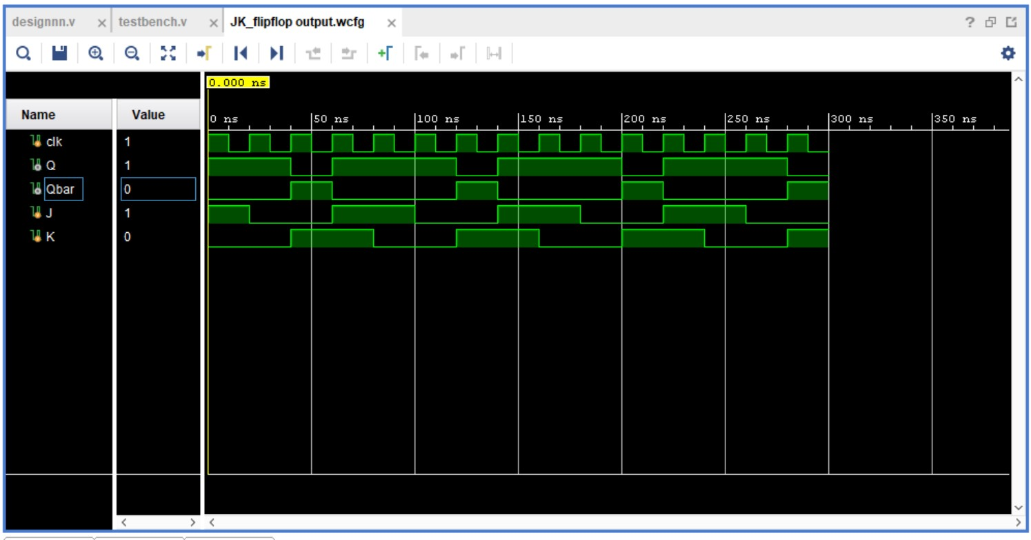

THANK

YOU